Milestone One
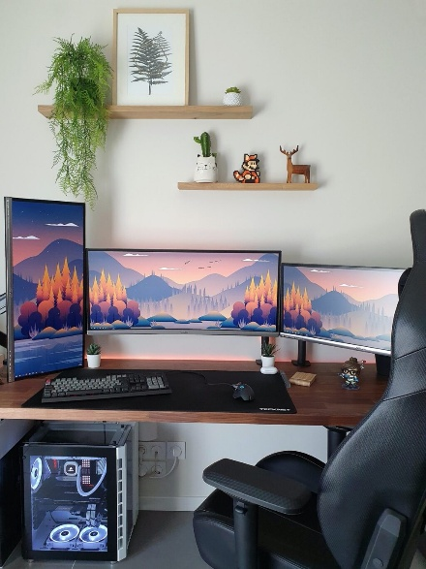
2D Image Selection
For this project, I selected a 2D image of a modern computer desk setup that includes a desk surface, multiple monitors, and input devices. This image was chosen because it is clean, well-lit, and clearly structured, making it easy to identify individual objects and understand their spatial relationships. The separation between objects and the visible depth differences allow scale and distance to be interpreted accurately, even from a single image.
The scene provides enough visual information to infer object placement and proportions without ambiguity. This makes it a strong reference for recreating the scene in 3D using OpenGL while avoiding unnecessary complexity.

Objects to Be Replicated in 3D
From the selected image, the following objects will be replicated in the 3D scene: the desk surface, the center computer monitor, the keyboard, and the mouse. These objects were chosen because they are central to the scene and clearly visible in the reference image. Together, they form a recognizable workstation environment while remaining appropriate in complexity for this project.
The monitor is particularly well suited for this milestone because it can be constructed using multiple basic 3D shapes, which satisfies the project requirements and allows for more detailed object composition. Other items in the image, such as the PC tower and wall shelves, were intentionally excluded to keep the project scope manageable.
Basic 3D Shapes Used to Replicate the Objects
The desk surface will be represented using a scaled plane. A plane is appropriate because the desk surface is flat and does not require volumetric depth to appear visually accurate. This plane will act as the grounding element for the scene and provide a reference surface for positioning all other objects.
The computer monitor will be created using multiple basic shapes: a box for the screen and frame, a tapered cylinder for the vertical stand, and a box for the base. The monitor naturally separates into these components, making it an ideal multi-shape object. Using simple geometric primitives allows the monitor to maintain correct proportions while remaining efficient to render.
The keyboard will be modeled as a single flattened box. Individual keys will not be modeled to avoid unnecessary geometric complexity. This approach preserves the overall shape of the keyboard while allowing surface detail to be added later through texture mapping.
The mouse will be created using a combination of a flattened cylinder for the curved top and a thin box for the base. This combination allows the mouse to appear more realistic than using a single shape while still keeping the object achievable within the project scope.
Scope and Feasibility
The selected scene is both visually interesting and achievable because each object can be constructed using basic 3D shapes and standard transformations such as translation, rotation, and scaling. The scope has been intentionally limited to avoid over-modeling while still demonstrating an understanding of scene composition and object construction. This approach allows for flexibility in later milestones while ensuring that the core requirements of the project are met effectively.

